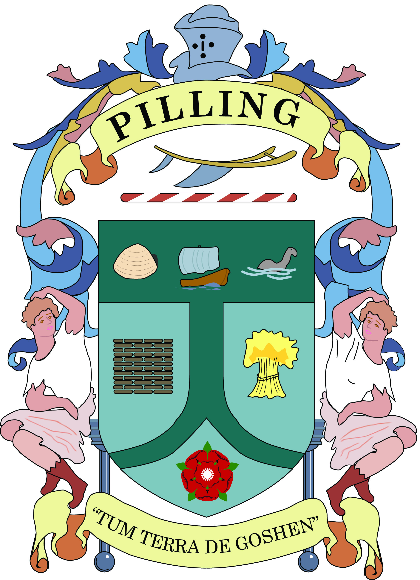
PILLING PARISH COUNCIL MEETINGS
Public Attendance Policy

By law a Parish Council is required to abide by certain legal regulations. The following may offer some assistance to members of the public to understand how a Council Meeting works.

How is the Council made up?
A Parish Council is elected by the electorate of the area to serve as a body to decide upon and provide local facilities and fulfil requirements.
Pilling Parish Council is made up of 10 Councillor seats, managed by a Chairperson.

How are Meetings called and conducted?
By law, an agenda for a Parish Council meeting must be posted in a public place three clear days prior of the meeting date, similarly Councillors require three clear days’ notice and so is sent out a week before. Only business contained within the agenda can be considered at the meeting.
A Parish Council meeting is open to the public to attend, but is not a public meeting. This means that the meeting is held for the Council to conduct its business, in an atmosphere conducive to working and the public are permitted to attend to watch and listen to proceedings.

Are Residents allowed to speak or contribute?
It is not a necessity or requirement in law that the public are allowed to speak at a Parish Council meeting, but it is often good practice for a Parish Council to allow a section of time at the beginning, within or at the end of a meeting to hear residents’ views. Pilling Parish Council does, when residents attend, set aside time for them to speak.
The public should note that councillors are not bound to answer any questions asked “there and then” and may defer to a written answer which would be published on the council website and may be promoted via social media. Under no circumstances will any decisions be made by the Council during the public session – a matter that arises under the public session may be added to the agenda of a subsequent council meeting or committee for full an proper consideration by members and ensure full notice of the matter to the public not at the meeting.
The rules of debate during the public session are clear and are set out in the council’s Standing Orders.

The public will be allowed to speak, at the given time, as long as it is clearly understood that they must not take part at any other time (see guidance overleaf).

What are Standing Orders?
These are a set of instructions to regulate the Councils business and proceedings, besides the statutes and laws laid down by Government, which govern how a Parish Council runs.
The term used by the Council, ‘suspend Standing Orders’ means it is suspending the official Council Meeting to allow it to be opened up for the public to offer its contribution before ‘restoring Standing Orders’ which is when it becomes again the official meeting and the public must not take part.

What about ‘bad behaviour’ at a Council meeting?
Councillors are bound by the Local Government Code of Conduct for Councillors and the Council’s Standing Orders. They must conduct themselves properly and abide by the Chairperson’s rulings. If not, they can be asked to speak no longer, be asked to leave the meeting, or be removed.
Members of the public disturbing a Council meeting will be asked by the Chairperson to desist in any behaviour considered to be disrupting the meeting. If the behaviour continues Council can resolve, without discussion, that the person(s) withdraw from the meeting, or be removed.
If a meeting becomes unmanageable because of interruption, or impossible to be continued due to disturbance or disregard for the Chairpersons instructions the Council can and will resolve to either close the meeting for a period of time or have the meeting recalled for another date.

Procedure for A MEMBER OF THE PUBLIC to speak or raise issues at Council meetings?
If at all possible, or feasible, make a call prior to the meeting to the Clerk to inform you wish to speak or raise an issue at a forthcoming Council meeting. This is because, if there is information the Clerk can bring along to the meeting or research before the meeting which may help with the query or the Councillors - the Clerk will be able to do this.

If you wish to raise an issue at a meeting.
1. Try to speak to the Clerk or Chairperson prior to the meeting start to inform you wish to speak or raise an issue in the public section, or if it is regarding a specific agenda item.
2. When the meeting reaches the agenda item of ‘public participation’, the Chairperson will announce that members of the public will be allowed to speak. At this point Councillors should not interrupt or debate issues with the public, but sometimes, if it is counter-productive not to, they may respond, but debate or long discussions should not take place between the public and the Council as this is the ‘public’ section. The Chairperson may limit a member of the public to 3 minutes of speaking in order to ensure the smooth running of the meeting. Overall the public participation section of the agenda will typically be limited to 20 minutes although the Chairperson may at their discretion extend this 3. When all the members of the public have spoken in the public participation section or the time period has elapsed, whichever is the sooner, the Chairperson will move onto the next item on the agenda.
4. During the public participation the Council may consider the item(s) raised by the public, and determine:
a) if it is a matter the Parish Council can legally consider and make any decisions on;
b) if it is a matter which can be referred by the Clerk to another authority, or;
c) if it is an item which will need a Council decision or expenditure and so would need to go onto a future agenda. The item will then be referred to a future agenda.
No legal decisions or expenditure can be made on any item raised at a meeting (by public or Councillor) because the item would not have been legally notified on an agenda in advance to the electorate or the Council.

Notes for Councillor consideration:
If the item being raised in the public section is of ‘personal or prejudicial’ interest to yourself, because maybe you live close, or will be affected etc. - you should be mindful to consider if you need to declare that interest officially and abide by guidance as to ‘declaring an interest’.

The ‘public participation’ section is the opportunity for the public to interact with the Council and the time set aside should be regarded as the public’s time. Debating or disagreeing with points within the public section will eat into this time and should be discouraged until the item is brought onto a future agenda for debate and decision.

September 2024

